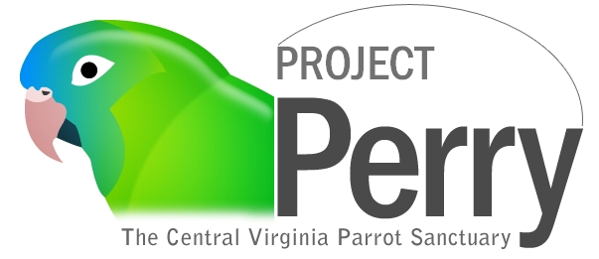

Due to the large number of requests for birds to live as permanent residents at the Sanctuary, we now have a mandatory form for you to fill out so we may review these requests to our best ability. Acceptance of birds depends on available resources such as space and funding. All requests will be reviewed and considered, however submission of a request does not imply or guarantee acceptance. If we are able to accept your bird as a resident at the Sanctuary, you will hear back with us within 2 weeks of submitting the request. We may need more information from you in order to make a final decision. Decisions are made by Staff and/or Board Members of Project Perry Inc. based on how well we feel the bird(s) will integrate and thrive in one of our environments. You must fill out the form on the next page in its entirety and email it, along with at least two photographs but no more than five, to matt@projectperry.com to be considered. Photographs must have good lighting and clear & focused of your bird(s) and your bird’s current environment. Even after submitting this form, please continue to research other options for your bird’s placement in the case that we are not able to accept your bird(s). Failure to provide us the requested information, including photos, will result in your request to not be considered – the more detailed information you can provide us, the better it will help us to make a decision. If you do not wish to place your bird(s) with us at this time but are instead interested in Estate Planning for your bird’s future, please contact us separately in email or phone. Thank you for your consideration to entrust us with your bird(s).

Your Name and Phone Number:

Name of Bird(s):

Species:

Age, if known:

Male or Female?

Wild-Caught or Captive-Bred or Don’t know?

Has the bird ever been a breeder bird and if so, when and for how long?

Can your bird fly? Please explain skill (or lack thereof) level:

How does your bird get along with other birds, if known?

Explain your bird’s preferences and behaviors with humans:
Has your bird ever been sick or needed surgery?

How often has the bird been to the vet for wellness checks?

Would you be able to provide us with veterinary records if admitted as a resident?

Do you feel this bird is in a situation in which he/she needs to be rescued and admitted under our rescue program? If so, please explain the circumstances in as much detail as possible.

Does your bird not need to be considered as a rescue case and you are, instead, interested in our Lifetime of Care program?

If you are interested in Lifetime of Care for your bird, have you read and understood the guidelines and policies for Lifetime of Care as outlined on the website and understand that you will be financially responsible for your bird’s care?

If we are not able to take in your bird as a permanent Sanctuary resident, are you open to an adoptive home?

Please provide any additional pertinent information that you feel might be useful in our decision including the reason(s) why you need to find placement for your bird(s):

